The Anointing
Bethany Reformed Church Monthly Newsletter/ April 2025

Bethany Reformed Church
bethanyreformedchurch@gmail.com
bethanyrcsd.org
605-987-5645
Office Hours
Monday – Thursday
8:30a.m.-5:30p.m.
Friday 8:30a.m.-12:30p.m.

Worship Service
Sundays 10:00-11:15a.m.
Discipleship Classes (Sept.-May)
9:00-9:45a.m.

Koffee with Kevin
The first and third Wednesday of every month from 10:00-11:30a.m.

Staff
Kevin Schneider, Pastor
Jill Devitt, Office Administrator
Lenae Wiersma, Custodian
Maddy Schneider, Youth/Worship
Carol Van De Stroet, Treasurer
Shelly Swift, JAM Preschool


Benefits of Praising God
As Christ-followers, we build many important spiritual habits into our lives including prayer, Bible reading, gratitude, and so on. All of them will play a critical role in our spiritual journeys. But we must not forget the habit of praising God. It’s particularly important when we’re struggling.
Praise lifts your spirit.
Psalm 42:5-6 says: “Why, my soul, are you downcast? Why so disturbed within me? Put your hope in God, for I will yet praise him, my Savior and my God. My soul is downcast within me; therefore, I will remember you from the land of Jordan, the heights of Hermon.” There’s no doubt we have a lot in our world today to be discouraged about. But Psalm 42 reminds us to both praise God and remember what he has done in our lives when we’re down.
The world is looking for hope. As Jesus-followers, we know the only real reason for hope. That’s why worship is so energizing. It takes your eyes off your troubles and puts them on Jesus.
Praise helps you sense God’s presence.
God is always present whether you sense it or not. Sometimes we don’t feel his presence, but that’s because we’ve moved away from him. He hasn’t.
When you don’t feel God’s presence is when you need to praise him the most. It’s easier to act your way into a feeling than feel your way into an action. The Bible says, “Surely the righteous will praise your name, and the upright will live in your presence.”
(Psalm 140:13).

(continued on page 2)
(Benefits of Praising God continued…)
Praise enlarges your perception of God.
The Bible tells us in Psalm 69:30 “I will praise God’s name in song and glorify him with thanksgiving.” When we look at something with a magnifying glass, it gets bigger. When God gets bigger, our problems get smaller. Either your problems will be big, or God will be big. It’s your choice.
Praise reveals solutions we can’t see.
We all have issues in our lives we simply can’t figure out. They tie us up in knots. Psalm 73:16-17 describes this kind of situation: “When I tried to understand all this, it troubled me deeply till I entered the sanctuary of God; then I understood their final destination.” The sanctuary of God is a metaphor in this Psalm for coming into the presence of God. It was through worshiping God that the writer got his answer.
Praise helps us remember God’s blessing.
Often when we’re thinking about a big problem, it’s all we can think about. It colors everything in our lives. That’s why when you have a fight with a loved one, it tends to become everything you think about.
Praise will correct the imbalance. It’ll remind you that not everything in your life is bad. In Psalm 105, the Bible describes this pattern: “Give praise to the Lord, proclaim his name; make known among the nations what he has done. Remember the wonders he has done, his miracles, and the judgments he pronounced.” (Psalm 105:1, 5). When you have problems, you tend to focus on the negative. Praise helps you remember who you are and who God is.
Praise enlists God’s protection.
When you praise God for an answer to your prayer before it happens, that’s faith, and that’s when God begins to fight for you. In 2 Chronicles 20, we read about three enemy nations who ganged up on Israel. The only chance Israel had was for God to miraculously save them. So, King Jehoshaphat organized an unusual battle plan. He put a choir in front of the army as they marched into battle. The Bible says as soon as the Israelites started praising God, confusion ensued, and the enemy was defeated. The Lord wants to fight your battles too, so take time to praise him in advance.
Praise breaks chains and opens doors.
You probably have certain things holding you back. You might feel stuck, like nothing has changed in your life for the better. It sounds odd, but there’s no better time for you to thank God than right now.
Paul did this in Acts 16 while he was in prison with Silas. In the middle of the night, the two decided to have a praise session. As they praised God, the Bible says, “Suddenly there was such a violent earthquake that the foundations of the prison were shaken. At once all the prison doors flew open and everyone’s chains came loose.” Acts 16:26.
That story is a miracle, but it’s also a metaphor of what God does in our lives when we praise him. When you need to be set free from an attitude, an addiction, or habit, praise God. It’ll break the chains holding you back.
My challenge for you is to learn to make praise your natural response for everything you face, good or bad. Develop that habit in your life and encourage others to do the same and then see what God does.
Article taken from Pastors.com






March’s Current Giving Report
General Fund $30,827.48
Thank you for your generosity!
To tithe now,
Scan the QR Code
or
Text GIVE to 605-702-2209.

None of the work we do at Bethany would be possible without God moving the hearts of people to give. Thank you!

STAY CONNECTED

Join our Facebook page!
Bethany Reformed Church, Canton, SD

Check out our website!
www.bethanyrcsd.org

Join our Instagram page for Youth news!
Bethanyreformedchurch

Download our church app for the directory
and event calendar!
SFConnect Directory App

Hold Fast
Middle School Retreat 2025
“In the midst of life's storms, find your anchor in Christ.”
April 11-13, seventeen middle school students and 3 adults will attend a retreat in Dayton, IA. They will listen to speaker Tracy Cleveringa, worship with the NWC Worship band, and be encouraged to stand firm in their faith, trusting in God's promises.
Please pray for the students and adults as the weekend draws near. Pray for hearts and minds to be opened and seeds to be planted.

Holy Week Services
Palm Sunday marks the beginning of Holy Week and the start of the final week of Jesus' earthly ministry. Join us Sunday, April 13, at 10:00AM for Worship. Andy Hille will preach.
Maundy Thursday - The community will put on a Living Last Supper drama on Thursday, April 17, at 7:00PM in the high school commons.
Good Friday - Worship with us Friday, April 18, at 7:00PM for “The Rest of the Story.”
Easter Sunday - Join us at 10:00AM as we celebrate Christ’s Resurrection. Communion will be served.

“The resurrection of Christ changed the midnight of bereavement into a sunrise of reunion; it changed the midnight of disappointment into a sunrise of joy; it changed the midnight of fear to a sunrise of peace.” Billy Graham, American evangelist

LADIES TEA
The annual Ladies Tea, hosted by the GEMS group, was held on Wednesday, March 26. (GEMS stands for Girls Everywhere Meeting the Savior) The 1st-5th grade girls were filled with excitement and eager to serve their guests! After a brief program, tea, snacks, games, and fellowship were enjoyed by everyone.
Thank you GEMS leaders and helpers for all
You did for these young ladies over the year.
Seeds were planted and love was poured into
them. If you are feeling a tug to help these
young girls in their faith journey, please contact
Jill in the church office.
GEMS Theme Verse
“And what does the Lord require of you?
To act justly and to love mercy and
to walk humbly with your God.” Micah 6:8

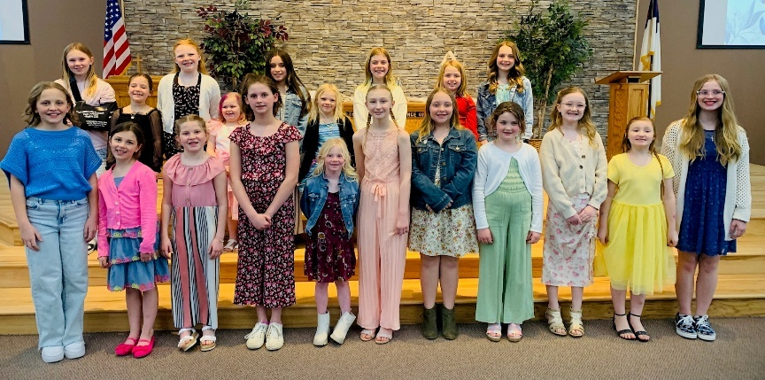

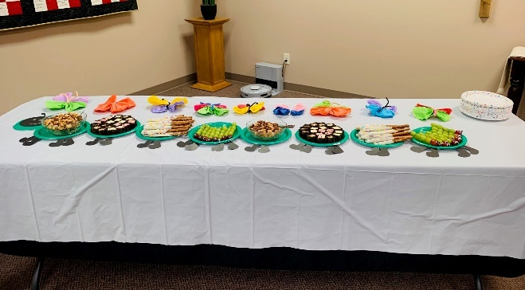



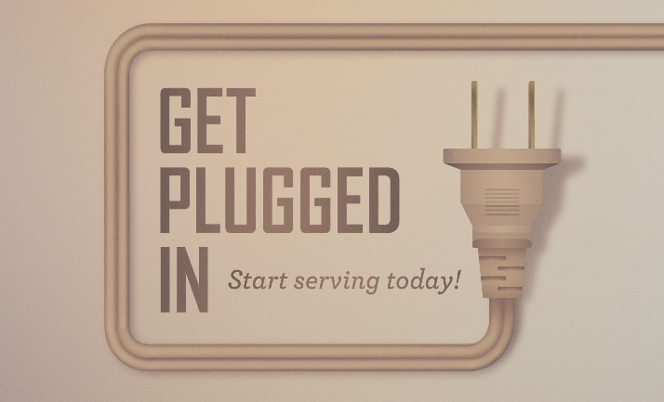
Midweek 2024-2025

The last Midweek will be Wednesday, April 30.
Thank you to everyone who helped! From the kitchen crew, leaders and helpers to the janitor. The year wouldn’t have run as smoothly without you!
We had a record number of students attending Wednesday evenings! Prayerfully consider letting Jesus use you in this ministry.
“I have no greater joy than to hear that my children are walking in the truth.” 3 John 1:4

There are many ways to volunteer and get connected at Bethany Church. We encourage you to contact Jill in the office to learn where you can serve. Whether it’s helping behind the scenes or something more in the front lines, there’s a place for you!

